September, 2019 Newsletter
Brewer Farms Newsletter
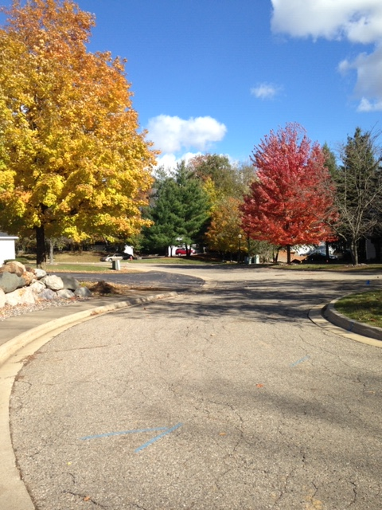

Upcoming Association Events
Brewer Farms Breakfast, 9 AM
October 11, 2019
November 8, 2019
December 13, 2019

Location to be announced.
Free breakfast for those celebrating their birthday or anniversary!
Everyone is welcome.

Welcome New Co-owners:
- James Diaz, Bldg K
- John Walker, Bldg G
- Paul Gray, Bldg N
- Betty Adams, Bldg D
- Fred & Peggy Pierson, Bldg E
- Dianne Matthews, Bldg K
- Victoria Reid, Bldg M

- Paul Gray
Building N

- Kelly Dykwell
Building P

www.brewerfarmscondos.com
President’s message:

CARE

Care
And
Respect
Everyone

We, the Brewer Farms Condominium Board members, care to hear from the community and attempt to respond appropriately.

The community includes each co-owner and when we listen, discuss and report we are committed to do so respectfully.

Because each of us shares our unit and grounds with others, it is hopeful that we CARE about everyone. Working together with a management company, New Horizon, we form a caring team.
Linda Kostich

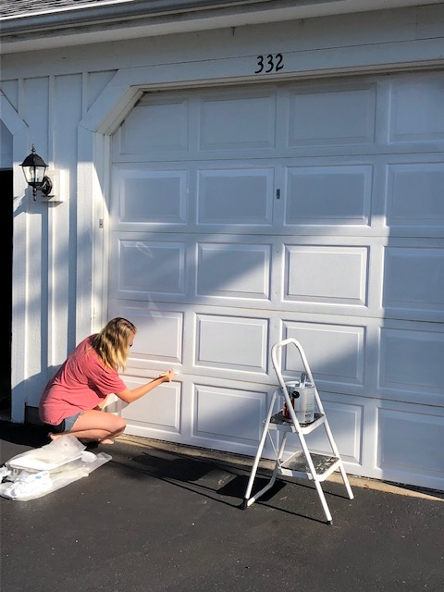
Painted five garage doors for her neighbors.
Now that is an act of CARING!!!

Association Board Meeting Highlights

It has been a busy but successful six months.
The Board approved several Summer Projects. Some of the big items are as follows:

Trimming and removing certain trees that potentially could have a negative impact on buildings and grounds. We are hopeful to replace some of the trees at a future date.

Recycle Bin Program – Two Bins (one on North Side (by building N), one on South side (by building H)). The recycling program appears to be a positive venture.

Gutters on several buildings were scheduled to be replaced towards the end of the Summer Season.
This project has been completed for 2019.

New Horizon was approved as the Lawn Care and Snow Removal Provider for 2019.Several lawn care items were approved for 2019. Some of the items include Cutting and trimming, edging, flea, tick, ant & mosquito control, Fall clean up, grub prevention, plus other general lawn care.

More economic lighting was approved and all has been changed out.

Power washing was completed on several buildings.

If you are interested in sharing your birthday and/or anniversary date, we would like to list it in our Quarterly newsletter.
Please contact Mary Rosenberry by email: mrosey52@gmail.com or call or text 269-275-6070 (leave message name and date(s)) or Linda Kostich by email: lindakostich@yahoo.com or
Phone 773-750-8424.

Tips from the Brewer Farms Board:

ARE YOU READY FOR WINTER?
Winter is fast approaching and it is important to remember with winter comes cold, cold, cold weather. It is very important for those of you that head to warmer climates to make sure that you turn off your water and drain your pipes to prevent them from freezing and bursting. We have learned over the years that just leaving your heat on at a low temperature is not always enough, especially when we get the below zero temps, Remember, your furnace room is outside on your patio and there are pipes out there that are exposed to the rigidly cold temperatures. It might be helpful to give a key to someone you trust a key so they are able to check your home to make sure it is a trouble free environment.

Also, for those of you that remain here, please be sure to spot check your furnace room during the cold weather to be sure that it is staying warm enough.

Everyone should check the furnace room for your unit routinely throughout the year to be sure that everything is in good working order. No drips from water heater, or any other issues that might arise. We tend to forget that room since it is not used on a daily basis.

DUMPSTER TIPS:
Please remember to place all trash in the dumpster. The trash company will not pick up any trash collection outside of the dumpster. DO NOT over fill the dumpster so that the lids will not close. If the dumpster nearest you is full – Please take your trash to another dumpster in the complex that might not be as full.

Remember that we have our two Recycling Bins (one at Bldg H & one at Bldg N). Cardboard boxes should be broke down and put in the Recycling Bin. Do not put recycling in plastic bags of any type. Loose items only. NO Styrofoam.

So far, the Recycling Bins have been well accepted in our community at Brewer Farms.

Still in Need of More

Volunteers for Committees

Looking for your
assistance and suggestions.
We have two available
committees to choose from:

Contact Mark Buckland at
419-360-1410 to join the
1-3-5-yr Planning Committee

Contact Mary Rosenberry at
269-275-6070 to join the Landscape & Gardens Committee

USEFUL CO-OWNER INFORMATION

** According to the bylaws Article VI, Section 2-Listing and Sale of Unit.
If you are going to put your unit up for sale, you must deliver a copy of your listing agreement to the Board within 2 days of signing. See article for further details.

** According to the bylaws Article VI, Section 8 – Vehicles – You are allowed to park 1 vehicle in a parking space and 1 in your garage for a total of 2 vehicles only – per Condo Unit. See article for further details on other restrictions for vehicle use. Please show Care and Respect to your neighbors.
Brewer Farms Association Contact Information:

Property Manager

New Horizon Property Management

Contact Teresa@newhorizonmi.com or

call 269-558-8122

Emergency Contact

For after hours, weekends and holidays only

call 269-317-6111 or

Phil Hanks at 269-986-5706
- Linda Kostich, President
773-750-8424, lindakostich@yahoo.com
- Mark Buckland, Vice President
419-360-1410, mbucko2004@aol.com
- Jim Petz, Treasurer
419-913-0060, nwohio43512@yahoo.com
- Mary Rosenberry, Secretary
269-275-6070, mrosey52@gmail.com
- Alex Kahn, Director
269-579-2630, alex.kahn.iv@outlook.com

