June 2020
Brewer Farms Newsletter
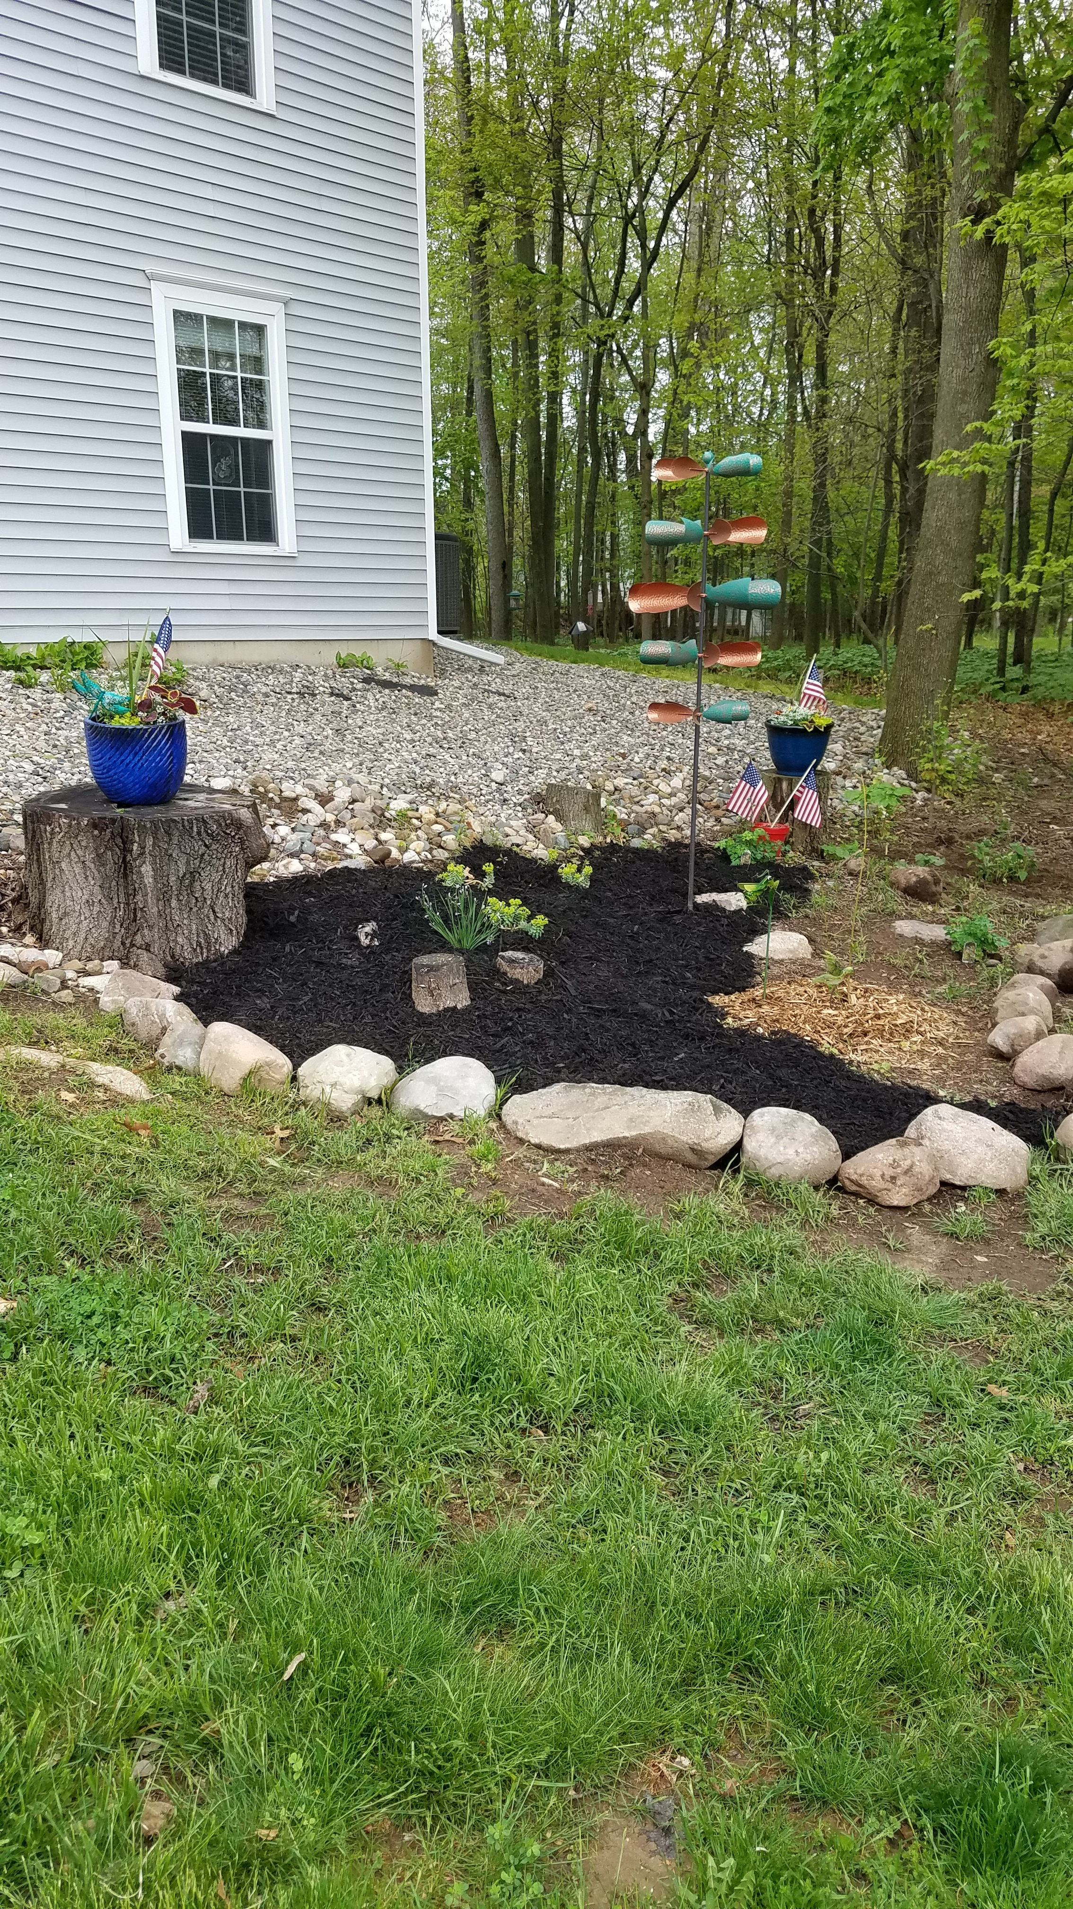

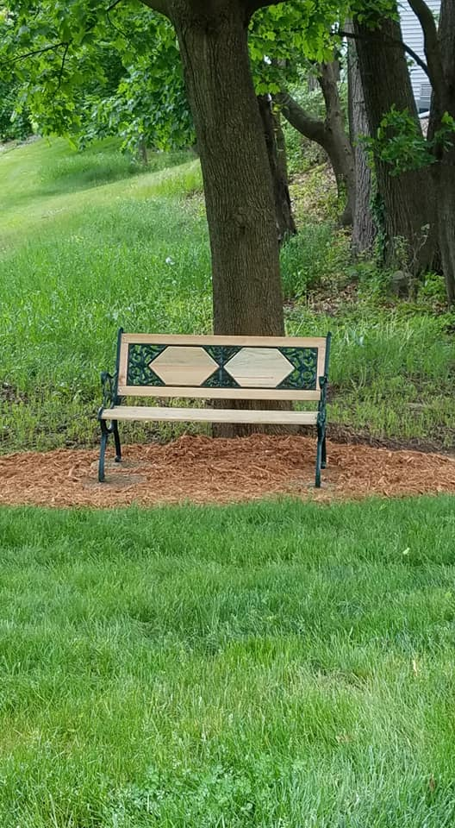

PRESIDENT'S MESSAGE

Happy Summer!!!
I hope all are staying healthy and safe,
and looking forward to changes soon.
The BFCA Board and New Horizon are grateful
for co-owner understanding during this unusual situation. Please be sure to offer thanks
for work being done to improve our community, including the Board's efforts and New Horizon.

Many PROJECTS were approved and
included in the 2020 budget.
We are hopeful that we can still complete them, some of the projects are:
Extended parking Bldgs. H and J
Painting
6" Gutter placements, started in 2019
Cement pads for recycling dumpsters,
moving one from H to E

ENJOY SUMMER, KEEP SMILING!!
Linda Kostich

A special thanks to all of the front line workers and volunteer’s i.e. medical and first responders, store clerks, truck drivers all essentials workers that have been there for us. We appreciate your service and dedication beyond words.

LIMITED GARDENING SERVICES REQUEST
Brewer Farms owners include all living on the north and south side of North Ave.
and we are requesting some volunteers to help maintain the already established areas.
Your donated time would be minimal, one hour as you are available.
You may contact Jane Marengo @ 269-781-0606 to coordinate the work to be done.
Your limited commitment would be an asset for all and very much appreciated.

SMOKE ALARMS
Please check your smoke alarms before they begin to fail. Observe the red light blinking repeatedly.
If you find no fire reason for this likely it is a low battery.
For those with high ceilings or unable to replace batteries yourself you may
contact the Marshall Fire Department. Non emergency phone number 269-781-3922

It has been nice seeing so many residents out and about walking or working in their garden areas. And sitting on the benches that are on the property. It is great to see that we as a community inside of Brewer Farms and in the beautiful City of Marshall, continue to stay strong and caring for our neighbors and strangers.

At this time, we WILL NOT be meeting for our monthly breakfast at Free Range.
We will continue to with the Stay Safe Mandate.
We hope to resume later this year.

Welcome New Co-owners:
- Erin Buchko Bldg E
- Nancy Moore Bldg F
- Joseph Tanner Bldg L

Upcoming Birthday’s: Mary Rosenberry June 21st, Elaine Phillips July 4th

Upcoming Anniversary: Walter ‘Doc’ & Mary Rosenberry July 2

Reminder: If you are interested in sharing your birthday and/or

anniversary date, we would like to list it in our Quarterly newsletter.

So far, we only have five names for birthday and/or anniversary announcements.

If decide to share please contact Mary Rosenberry by email: mrosey52@gmail.com or call or text 269-275-6070 (leave message name and date(s))

or Linda Kostich by email: lindakostich@yahoo.com or Phone 773-750-8424

Contact information

- Direct all calls to our Property Management Company:
New Horizon Property Management:
Phone: 269-558-8122
or by email -- Teresa@newhorizonmi.com

- Please visit our website: brewerfarmscondos.com
-----------------------------------------------------------------

Brewer Farms Condominium Association Contact Information:

Property Manager

New Horizon Property Management

Contact Teresa@newhorizonmi.com or

call 269-558-8122

Emergency Contact

New Horizon Property Management after business hours & emergencies only: Tom Bregg @ 269-986-1369

Phil Hanks at 269-986-5706

Brewer Farms Condominium Board Members

- Linda Kostich, President 773-750-8424
Email: lindakostich@yahoo.com

- Mark Buckland, Vice President 419-360-1410
Email: mbucko2004@aol.com

- Jim Petz, Treasurer 419-913-0060
Email: nwohio43512@yahoo.com

- Mary Rosenberry, Secretary 269-275-6070
Email: mrosey52@gmail.com

- Jim Schwartz, Director 269-986-5813
Email: jschwartz1013@gmail.com

Date Reminders
Sunday, June 21st Father’s Day
And the First Day of Summer

Saturday, July 4th Independence Day

Tuesday, August 4th Primary Election

August 16-22 Calhoun County Fair

Monday, September 7th Labor Day

Friday, September 11th Patriot Day
______________________________
All of us at Brewer Farms appreciate the improvement of the recycling bins items and breaking down of boxes. As well as the extra attention that is being paid to the trash dumpsters contents and closing of the lids.

Please keep the attached Recycling Flyer on the back of this Newsletter handy for a quick reference.

