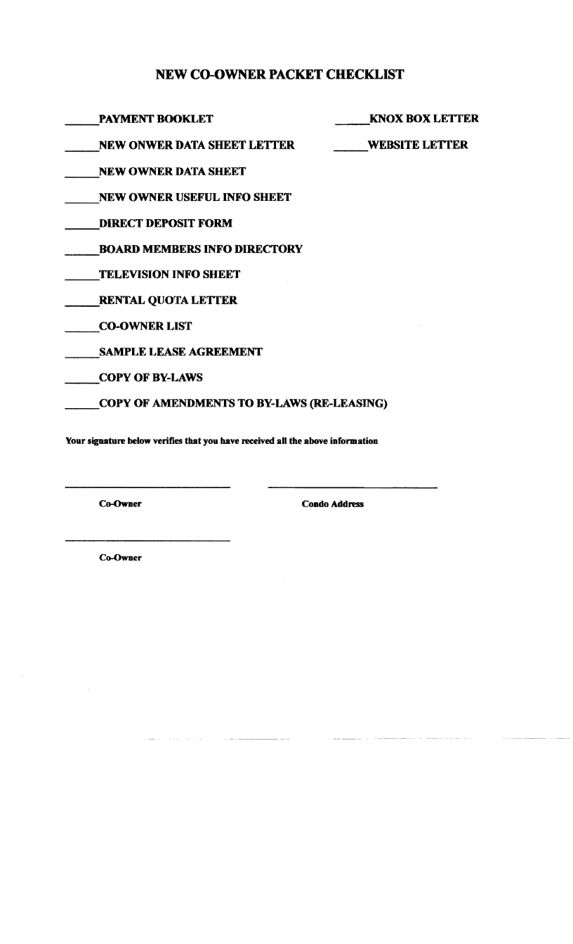

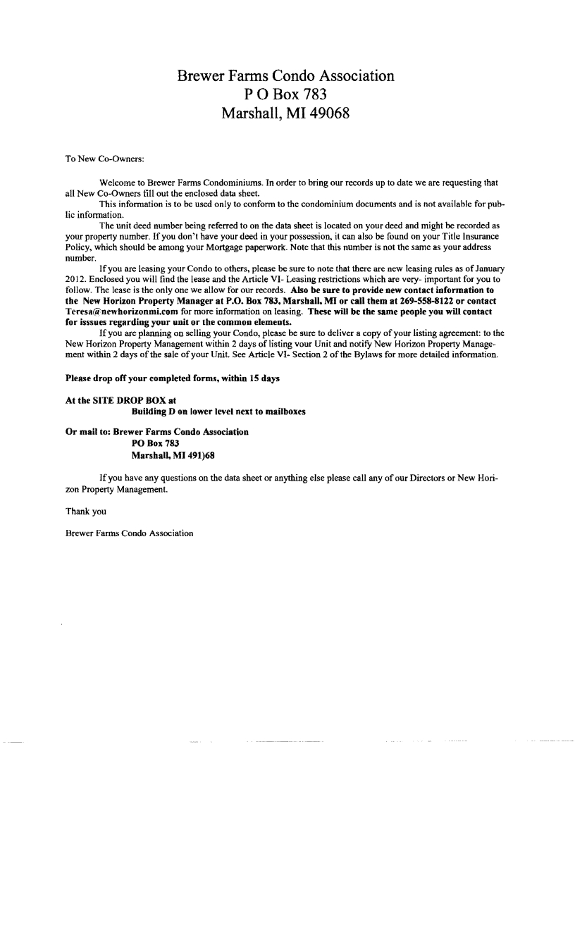

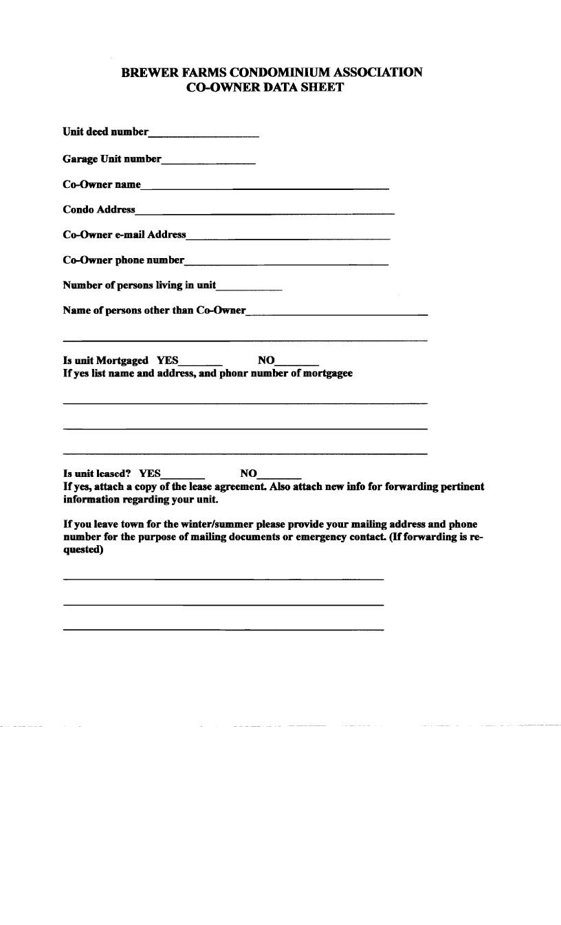

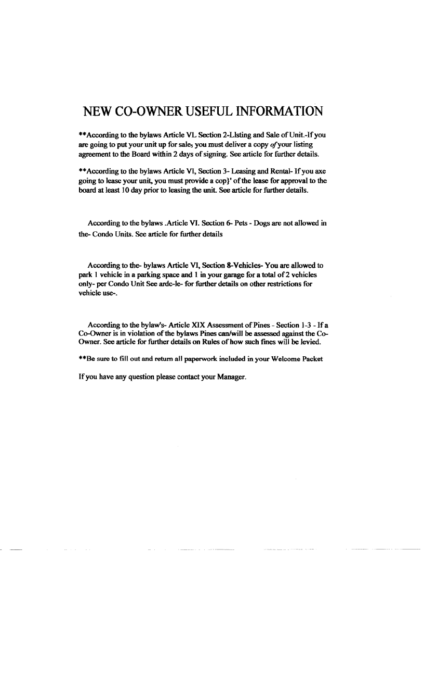

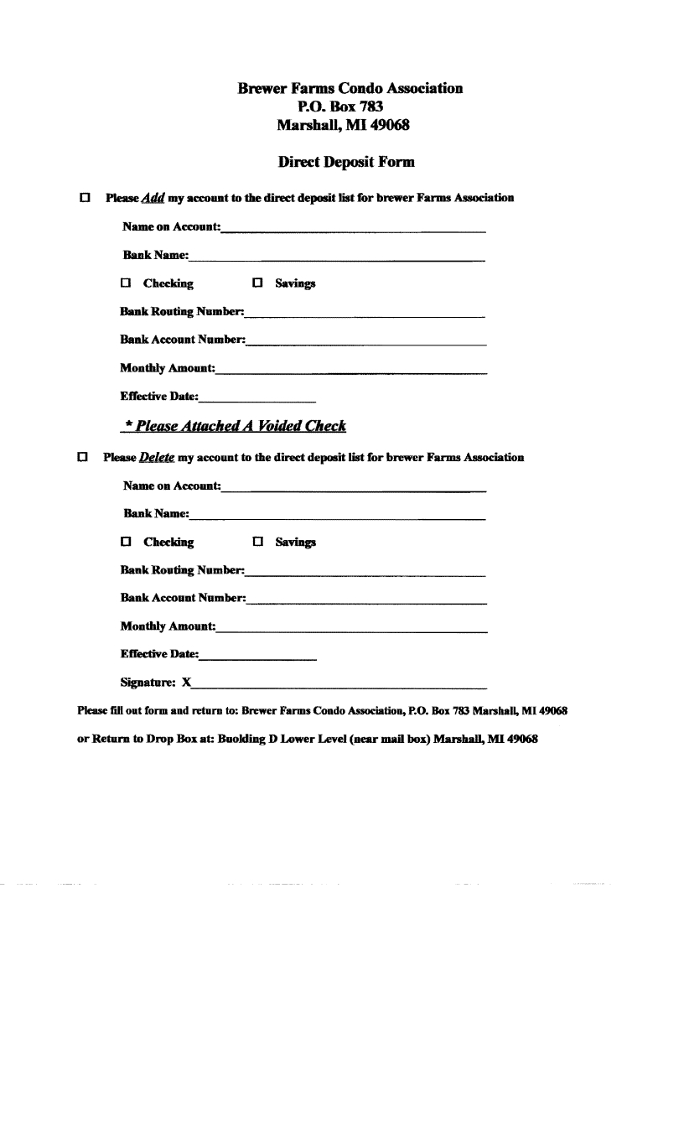

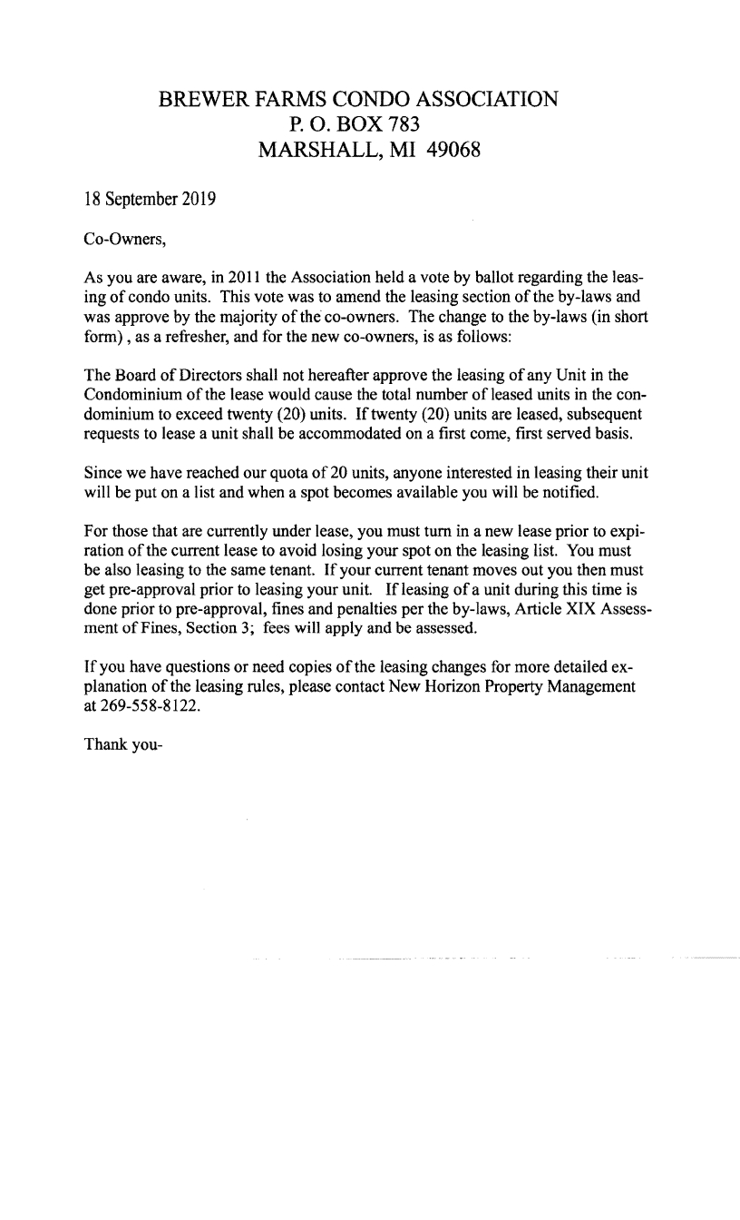

LEASE AGREEMENT

This Lease Agreement is entered by and between the Landlord. (Landlord) and Tenant (Tenant) as identified:
LANDLORD: __________________ TENANT: _______________
Address: __________________ Address: _______________

Landlord and Tenant agree to the following terms & conditions:

- Description. The Landlord, in consideration of the rents & covenants stated in this agreement, does lease to the Tenant the premises commonly known as Brewer Farms Condominium Unit No. ____ street address: ________________________, Marshall, Michigan.

- Rental Rate. Tenant agrees to pay to Landlord a total of __________________ and no/100 dollars ($ _______.00) each month for rent for the entire term. Payment shall be made in advance on the _________ day of each month. Rental payments and all written notices to Landlord required by this lease shall be payable to and delivered to: ______________________.

- Late Fees. If a rental payment is received after the date it is due, it is paid late. Tenant shall pay to Landlord a late fee equal to five percent (5%) of the amount of rent that is late. Partial payment of a month’s rent does not abate late fees. In addition to late fees. Tenant shall owe Landlord Thirty-five and no/100 dollars ($ 35.00) for any check that is dishonored. LANDLORD may terminate this lease because Tenants are chronically late with rent payments. Chronic rent payment is defined as paying rent after the due date on three or more occasions during the term of this lease.

- Term. This lease shall be for a term of __________________ months beginning _____________ and ending ___________________ unless terminated by either party according to this agreement.

- Use of Occupancy. Tenant agrees that the premises shall be used for residential purposes only. The maximum number of people who may occupy the premises at the above rental rate is _____ (__) persons. Not more than _______ additional persons staying longer than three (3) days, shall pay the sum of ________ and no/100 dollars ($______.00) after Tenant receives written approval from Landlord. Tenancy shall not exceed ________________persons.

Tenant agrees to use the premises according to all applicable regulations imposed by any governmental authority and to observe all reasonable regulations and requirements of any insurance company concerning the use and condition of the premises.
TENANT acknowledges that Tenant has received and read a copy of the BREWER FARMS CONDOMINIUM ASSOCIATION BY-LAWS and will abide by all of the provisions of articles VI, XIII and XIX thereof during the tenancy and acknowledges NO PETS ALLOWED.

